Pranav Pradeep Rao

prao43

August 29th 2018

**Martingale Project Report**

1. **In Experiment 1, estimate the probability of winning $80 within 1000 sequential bets. Explain your reasoning.**

The probability of winning in a single around of roulette, where the player is making an even money bet, is 0.47 (18/38). This is assuming an American style roulette is being used. If each bet is placed for an even money bet then the probability of a win is 0.47 for each sequential one, hence it is an independent event. The strategy used by Professor Balch is to bet one dollar initially, and if we wins he gets two dollars back. If he loses and he doubles the bet size until he wins and then starts back at one dollar. If the player has unlimited money then the probability of him reaching $80 in 1000 sequential bets is 100%. This can be observed in Figure 1 where after running 10 simulations with 1000 bets we observe that they all reach $80.

1. **In Experiment 1, what is the expected value of our winnings after 1000 sequential bets? Explain your reasoning.**

The expected value of a random variable is the long run average value of repetitions of an experiment. In this case the repetitions are the 1000 sequential bets repeated in 1000 separate simulations. The law of large number theorem can applied here, it states that the average result obtained from a large number of simulations is the expected value. Hence we can use the results of Figure 2 to say the expected value of experiment 1 is $80. I also had print statement in my code that calculated the plateauing mean value using the NumPy library.

1. **In Experiment 1, does the standard deviation reach a maximum value then converge or stabilize as the number of sequential bets increases? Explain why it does (or does not).**

Yes the standard deviation does reach a maximum in Figure 2 and Figure 3, this can be determined by two ways first the graphs start at the same point and then converge at approximately 210 bets for both figures implying they did reach a maximum value. I was able to calculate this using NumPy to be $4146.78 for Figure 2 and $8286.52 for Figure 3.These results make sense as we know that all simulations will reach the $80 target winnings in less than 1000 bets. Standard deviation is the variation of the data set values, which in this experiment is the mean or median winning earned per spin. As the number of bets increase more simulations reach the target winnings reducing the variation in the mean and median. They converge when all simulations have reached the target winnings of $80.

1. **In Experiment 2, estimate the probability of winning $80 within 1000 sequential bets. Explain your reasoning.**

This experiment is similar to experiment 1’s strategy except we start with a finite amount of money which is set to $256. In this case as we lose a bet we can double our bet size as long we do not exceed our $256 base amount. In this case some simulations will not be able to reach the goal of winning $80. To determine the probability of this I ran 1000 simulations of 1000 sequential bets out of which 614 were able to attain the target value of $80, the remaining lost the entire base amount and their winnings we set to -$256. Using thing I can approximate the probability of winning in Experiment 2 to 61%.

1. **In Experiment 2, what is the expected value of our winnings after 1000 sequential bets? Explain your reasoning.**

This is similar to Experiment 1 where we use the the law of large number theorem to determine the expected value from the average result obtained from a large number of simulations. This is demonstrated in Figure 4 which is calculated to be -$43.40 winnings per bet. This is inline with our understanding we know that not all simulations will be able to reach the target winning of $80. Approximately 40% will fail and consume the entire base amount of $256. Hence the mean winnings per bet will be lower as bets increase and simulations reach their final values.

1. **In Experiment 2, does the standard deviation reach a maximum value then converge or stabilize as the number of sequential bets increases? Explain why it does (or does not).**

Yes the standard deviations do reach a maximum value and stabilize but they do not converge to the mean or median graphs in Figures 4 and 5 respectively. The maximum value for Figure 4 is 162.40 and for Figure 5 is 163.96. As the number of bets increase only 60% of simulations will reach the target winnings of $80. Hence the simulations will have diverging data sets for both the mean and median winning per bet. The standard deviations will plateau when all simulations are complete and there is no change in the winnings as bets increase.

1. **Include figures 1 through 5.**

Figure 1: 10 separate simulations with 1000 bets

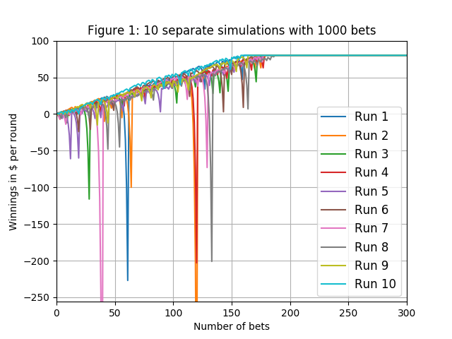

Figure 2: Mean values for each bet in 1000 simulations

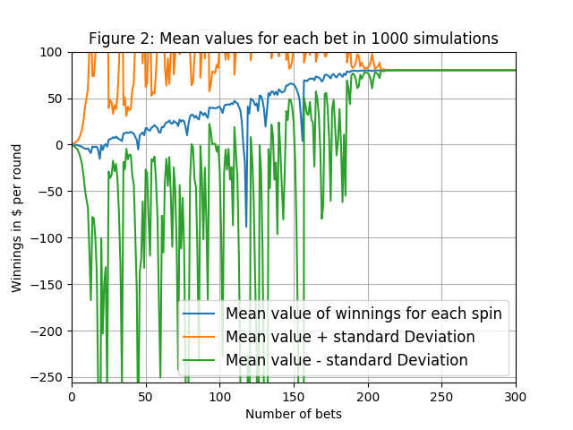

Figure 3: Median values for each bet in 1000 simulations

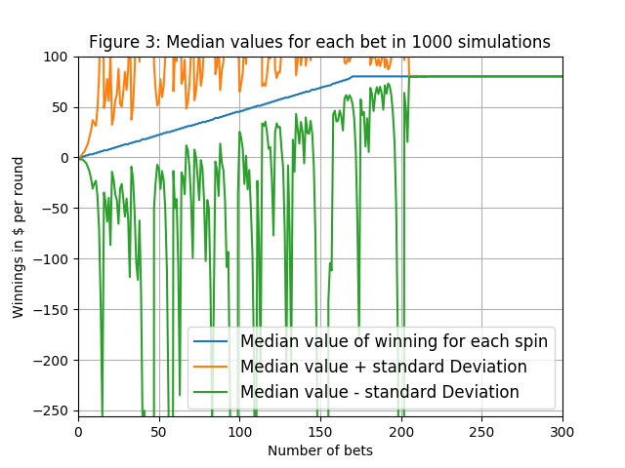

Figure 4: Mean values for each bet in 1000 simulations with restricted amount.

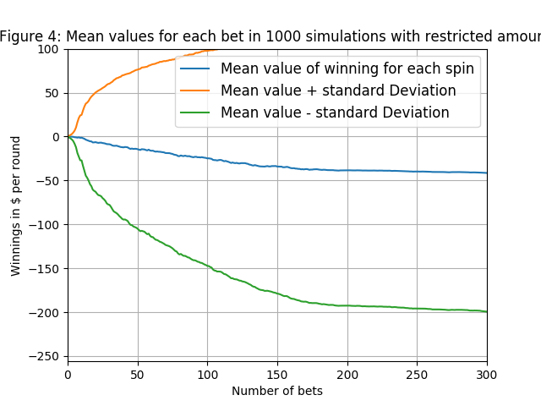

Figure 5: Median values for each bet in 1000 simulations with restricted amount.

